NAME : Bakhtawar Munir
CLASS : BSCS-E
CMS-ID: 588984
ASSIGNMENT # 01
FUNDAMENTALS OF COMPUTER PROGRAMMING
COURSE INSTRUCTOR : DR.SHAH KHALID

Q1: Write a C++ program that accepts the following information about a student: Marks (25)
- PROBLEM ANALYSIS:
Input:
Student registration number
Student name
Marks in programming fundamentals (out of 100)
Marks in mathematics (out of 100)
Marks in English (out of 100)
Process:
Add all 3 subject marks to find total marks
Divide total marks by 3 to find average marks
Calculate percentage using formula: (Total Marks / 300)*100
Output:
Display student info ,total marks, average marks, and percentage(formatted to 2 decimal places)
2) ALGORITHM :
Start
Ask user for student registration number and name
Ask user for marks in 3 subjects
Calculate total marks= pf marks + math marks + English marks
Calculate average marks= total marks / 3
Calculate percentage= (total marks / 300)*100
Show student info, total, average, and percentage with 2 decimal places
Stop
3) PSEUDOCODE :
START
INPUT reg num
INPUT student name
INPUT pf marks, math marks, Eng marks
total marks = pf marks + math marks + eng marks
average marks = total marks/3
percentage = (total marks / 300)*100
PRINT reg num, student name
PRINT total marks
PRINT average marks (up to 2 decimals)
PRINT percentage (up to 2 decimals)
END
4) FLOW CHART :
START

Input:reg No ,name

Input:pf,math,eng marks

Total marks=pfmarks+math marks+engmarks

Average marks=total marks/3

Percentage=(total marks/300)*100

Output:regno,name,totalmarks,avgmarks,percentage

END

5) C++ SOURCE CODE :
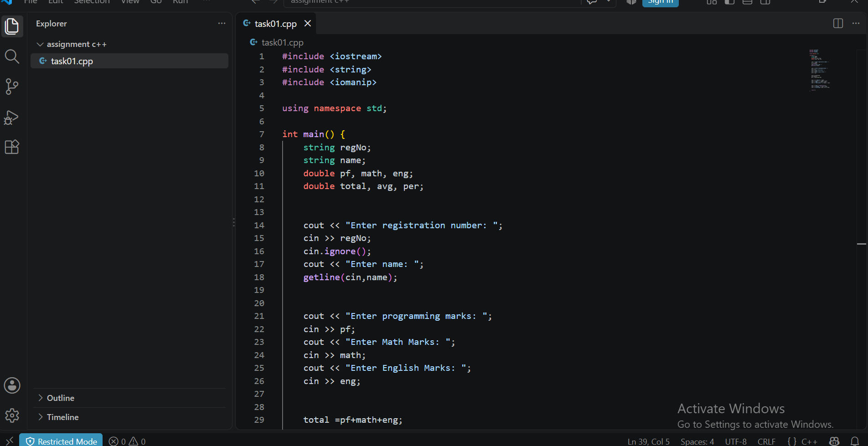

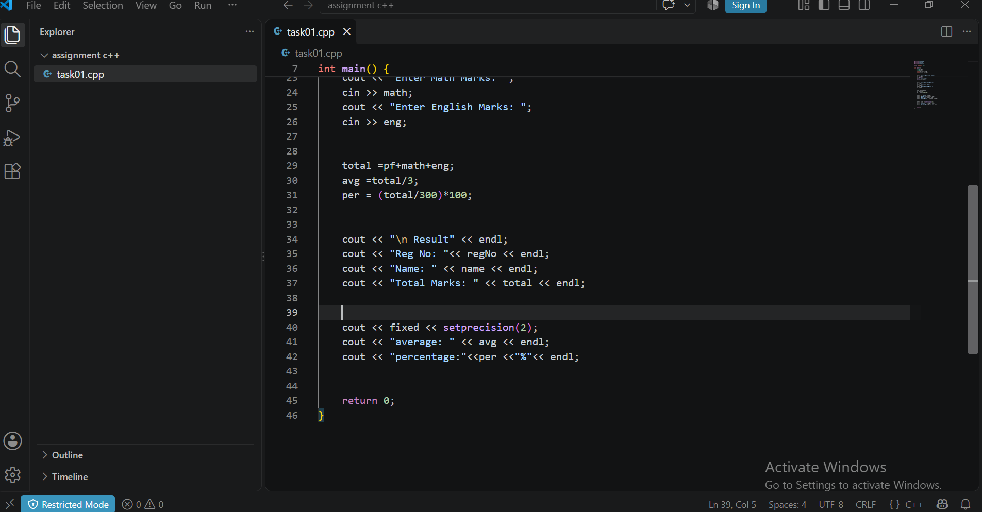

6) SCREENSHOT OF OUTPUT :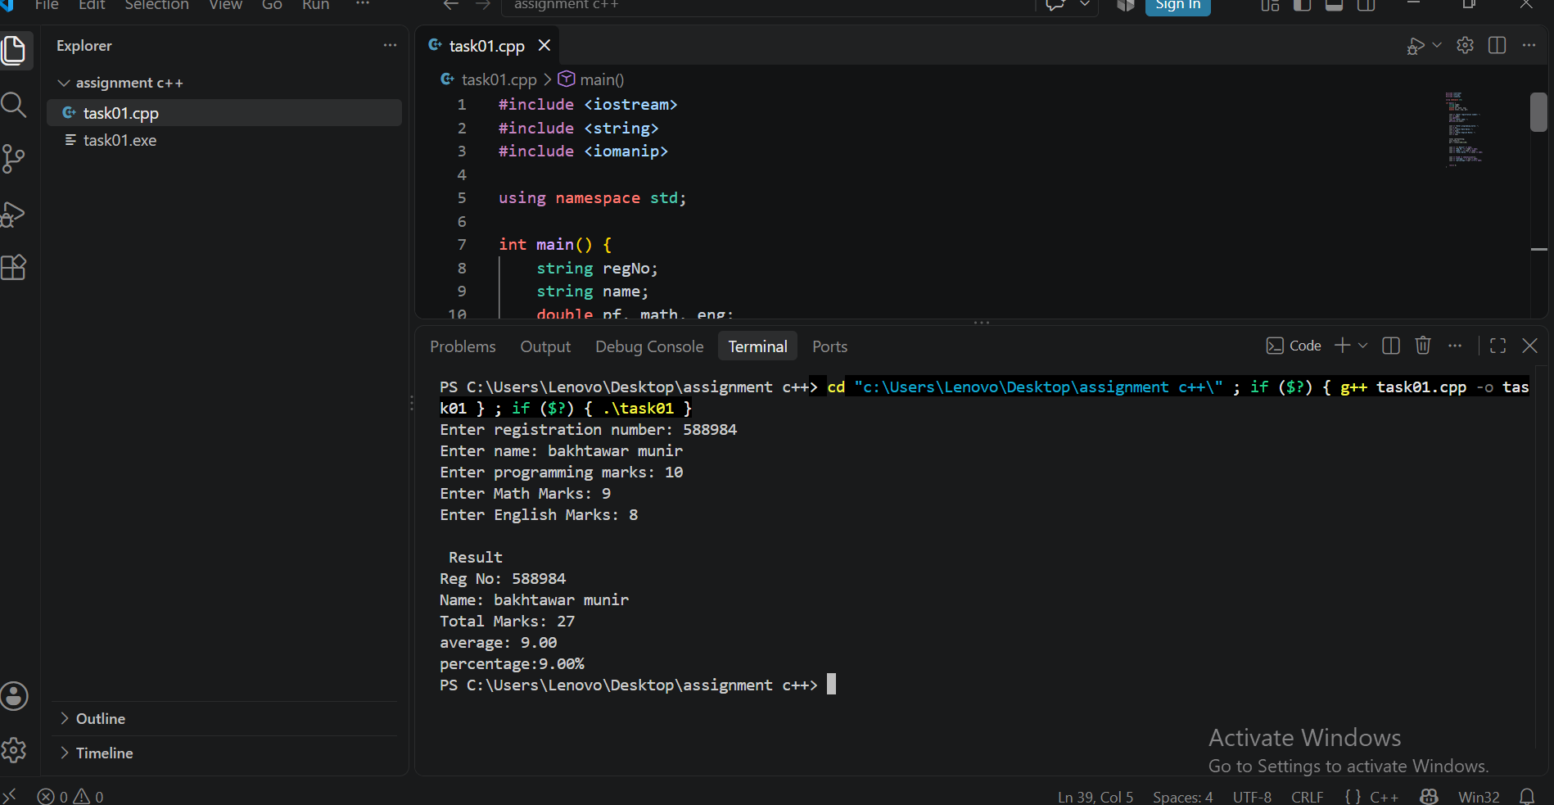

Q2: Write a C++ program that accepts a duration in seconds and converts it into: Marks (25)
1) Problem Analysis :
Input:
Total duration in seconds
Process:
Divide total seconds by 3600 to get hours (total seconds/3600)
Take remainder (total seconds % 3600) to get remaining seconds
Divide remaining seconds by 60 to get Minutes (remaining seconds/60)
Take remainder (remaining seconds%60) to get final seconds
Divide total seconds by 60to get total minutes representation (total seconds/60)
Output:
Display hours,minutes,and seconds
Display total minutes
2) ALGORITHM :
Start
Get total seconds from user
Calculate hours=total seconds/3600
Calculate rem sec=total seconds%3600
Calculate minutes=rem sec/60
Calculate seconds = rem sec%60
Calculate total minutes=total seconds/60
Print hours,minutes,seconds and total minutes
Stop
3) PSEUDOCODE :
START
INPUT total seconds
hours=total seconds/3600
rem sec=total seconds%3600
minutes=rem sec/60
seconds=rem sec%60
total minutes=total seconds/60
PRINT hours,minutes,seconds
PRINT total minutes
END
4) FLOWCHART :
START

Input:total seconds

Hours=totalseconds /3600

Minutes=remsec /60
Remsec=totalseconds/ 3600

Seconds=remsec%60

Totalminutes=totalseconds/60

Output:hours,minutes,seconds totalminutes

END

5) C++ SOURCE CODE :
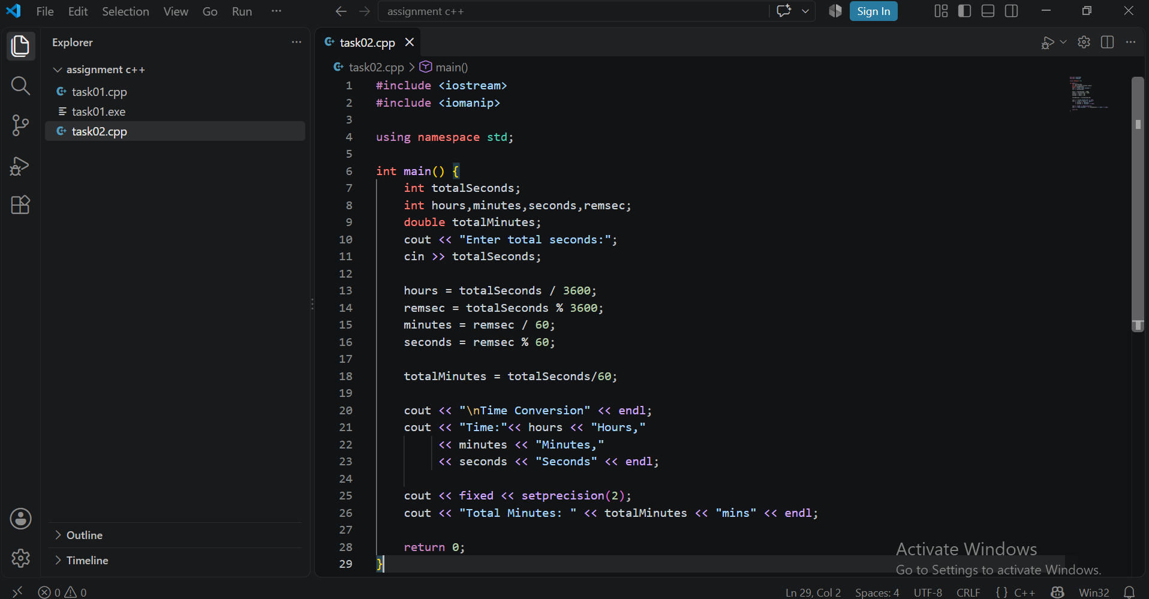
6) SCREENSHOT OF OUTPUT :
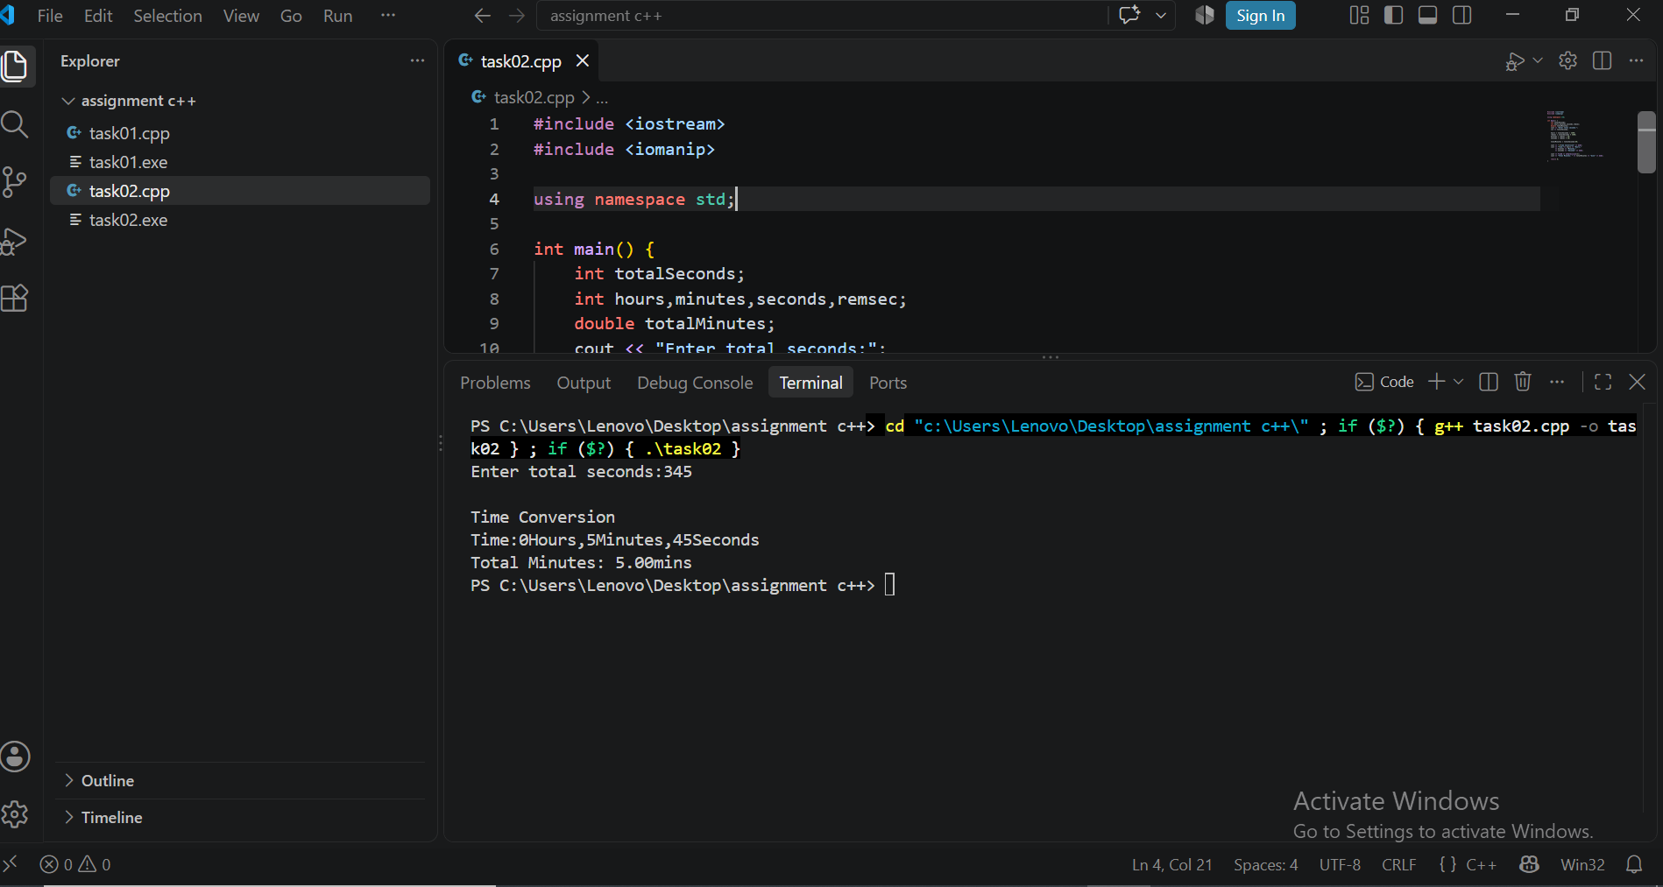

Q3: Write a C++ program that generates a simple salary slip for an employee. Marks (25)
1) Problem Analysis :
Input:
Employee name
Employee id
Basic salary
Process:
House rent=basic salary*0.2
Medical allowance=basic salary*0.1
Transport allowance=basic salary*0.05
Gross salary=basic salary+house rent+medical allowance+transport allowance
tax=gross salary*0.05
net salary=gross salary-tax
Output:
Display properly formatted salary slip showing all allowances, gross salary, tax deduction, and net salary up to 2 decimal places

2) ALGORITHM :
Start
Get employee name,employee id, and basic salary from user.
Calculate house rent allowance (20% of basic salary)
Calculate medical allowance (10% of basic salary)
Calculate transport allowance (5% of basic salary)
Calculate gross salary by adding basic salary and all allowances
Calculate tax deduction (5% of gross salary)
Calculate net salary by subtracting tax from gross salary
Print salary slips with values rounded to 2 decimal places
Stop
3) Pseudocode :
START
INPUT emp name
INPUT emp id
INPUT basic salary
House rent=basic salary*0.2
medical=basic salary*0.1
transport=basic salary*0.05
gross salary=basic salary+house rent+medical+transport
tax=gross salary*0.05
net salary=gross salary-tax
PRINT emp name, emp id
PRINT basic salary
PRINT house rent, medical, transport
PRINT gross salary
PRINT tax
PRINT net salary
END
4) FLOW CHART :
START

Input:emp name,empid,basic salary

House rent=basic salary*0.2

Medical=basic salary*0.1

Transport=basic salary*0.05

Grosssalary=basic+houserent+medical+transport

Tax=gross salary*0.05

Net salary=gross salary-tax

Output :salary slip

END
5) C++ SOURCE CODE :
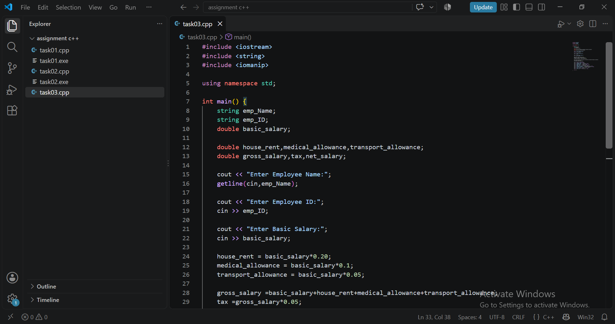

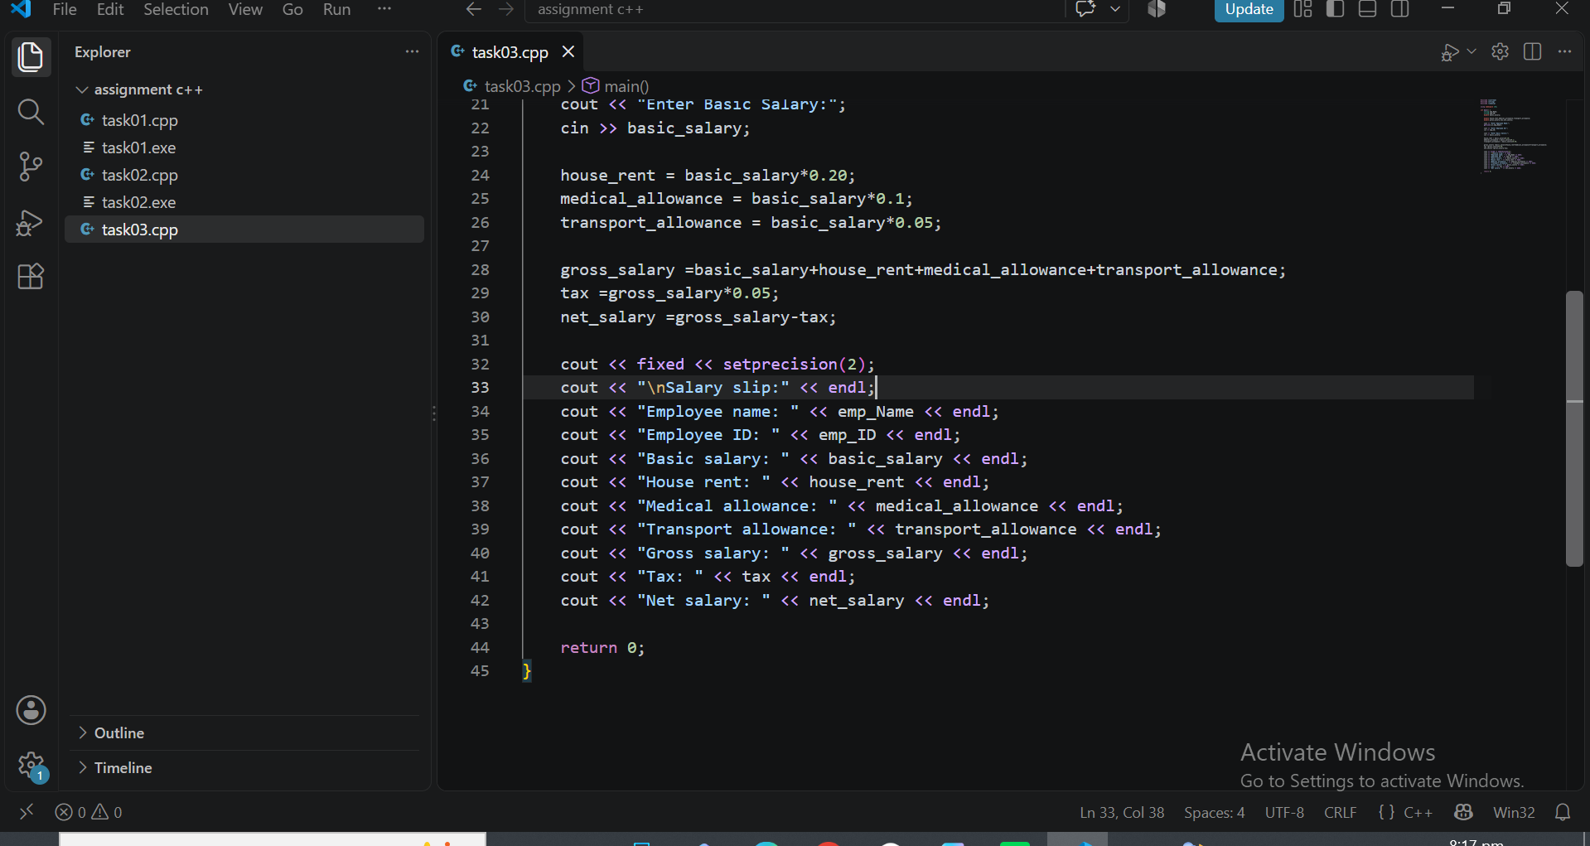

6) SCREEN SHOT OF OUTPUT :
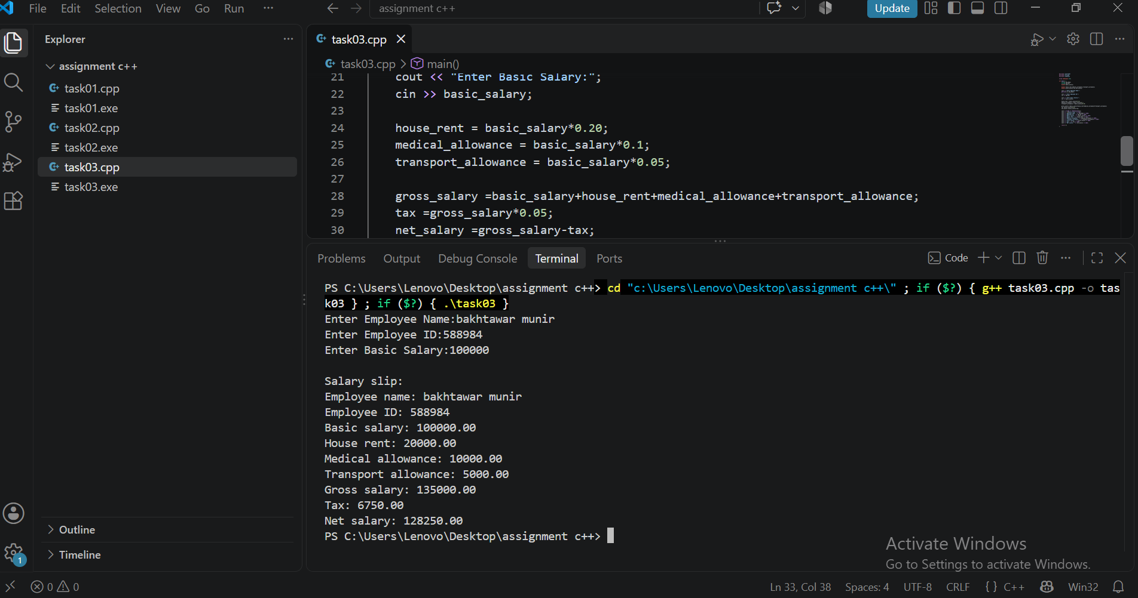

Q4: A bank wants to generate a summary of a customer's account transaction. Marks (25)
1) Problem Analysis :
Input:
Customer name
Account number
Opening balance
Deposit amount
Withdrawal amount
Interest Rate %
Process:
Balance after tx=opening balance+deposit-withdrawal
interest=balance after tx*(interest rate/100)
final balance=balance after tx+interest
Currency denomination calculations on int amount =final balance
Notes 5000=int amount/5000
rem=int amount%5000
notes 100=rem/100
remaining amount=(final balance-(int amount-(rem%100)))
total tx amount=deposit+withdrawal
deposit percent=(deposit/opening balance)*100
withdrawal percent=(withdrawal / opening balance)*100
Output:
Display all details, calculated balances,interest,currency notes count,remaining amount and percentages (round to 2 dp)
2) ALGORITHM :
Start
Get customer name,account number,opening balance,deposit,withdrawal and interest rate
Calculate balance after transactions(Opening+Deposit-Withdrawal).
Calculate interest amount (balance*Rate/100)
Calculate final balance (balance+Interest)
Calculate rs.5000,1000,500,and 100 currency notes using integer division and modulus
Calculate the remaining amount after currency distribution
Calculate total transaction amount (Deposit+Withdrawal)
Calculate deposit and withdrawal percentages relative to opening balance
Display the full bank transaction summary
Stop
3) PSEUDOCODE :
START
INPUT name, acc num
INPUT opening Bal,deposit,withdrawal,rate
Bal after tx=opening Bal+deposit-withdrawal
interest = Bal after tx*(rate / 100)
final Bal=bal after tx + interest
int Bal=INT(final bal)
n5000=int Bal/5000
rem=int Bal%5000
n1000=rem/1000
rem=rem%1000
n500=rem/500
rem=rem%500
n100=rem/100
rem Bal=final Bal-(n5000*5000+n1000*1000 +n500*500 + n100*100)
total tx=deposit+withdrawal
dep percent =(deposit /opening bal)*100
withPercent = (withdrawal / openingBal)*100
PRINT name, acc num
PRINT bal after tx,interest,final Bal
PRINT n5000, n1000, n500, n100, remBal
PRINT total tx,dep percent,with percent
END
4) FLOW CHART :
START

Input:name,acc num,openingbal ,deposit,withdrawal,rate

Balaftertx=openingbal+deposit-withdrawal

Interest=balaftertx* rate/100 Finalbal=balaftertx+ interest

Calculate notes:n5000,n1000,n500, n100 and rembal

Calculate:totaltx, dep percent,withpercent

Output :summary and denominations

END

5) C++ SOURCE CODE :
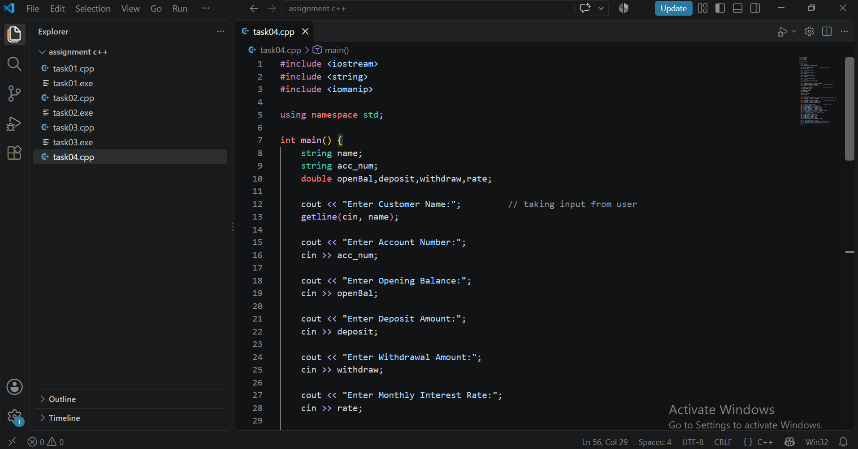

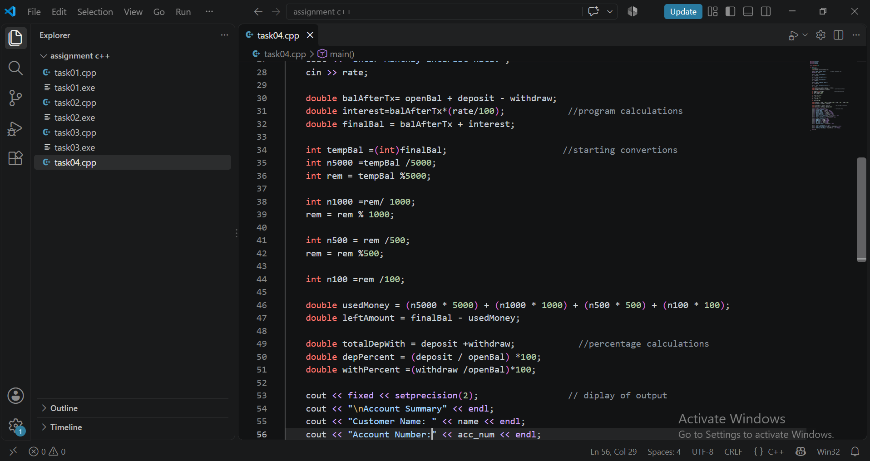

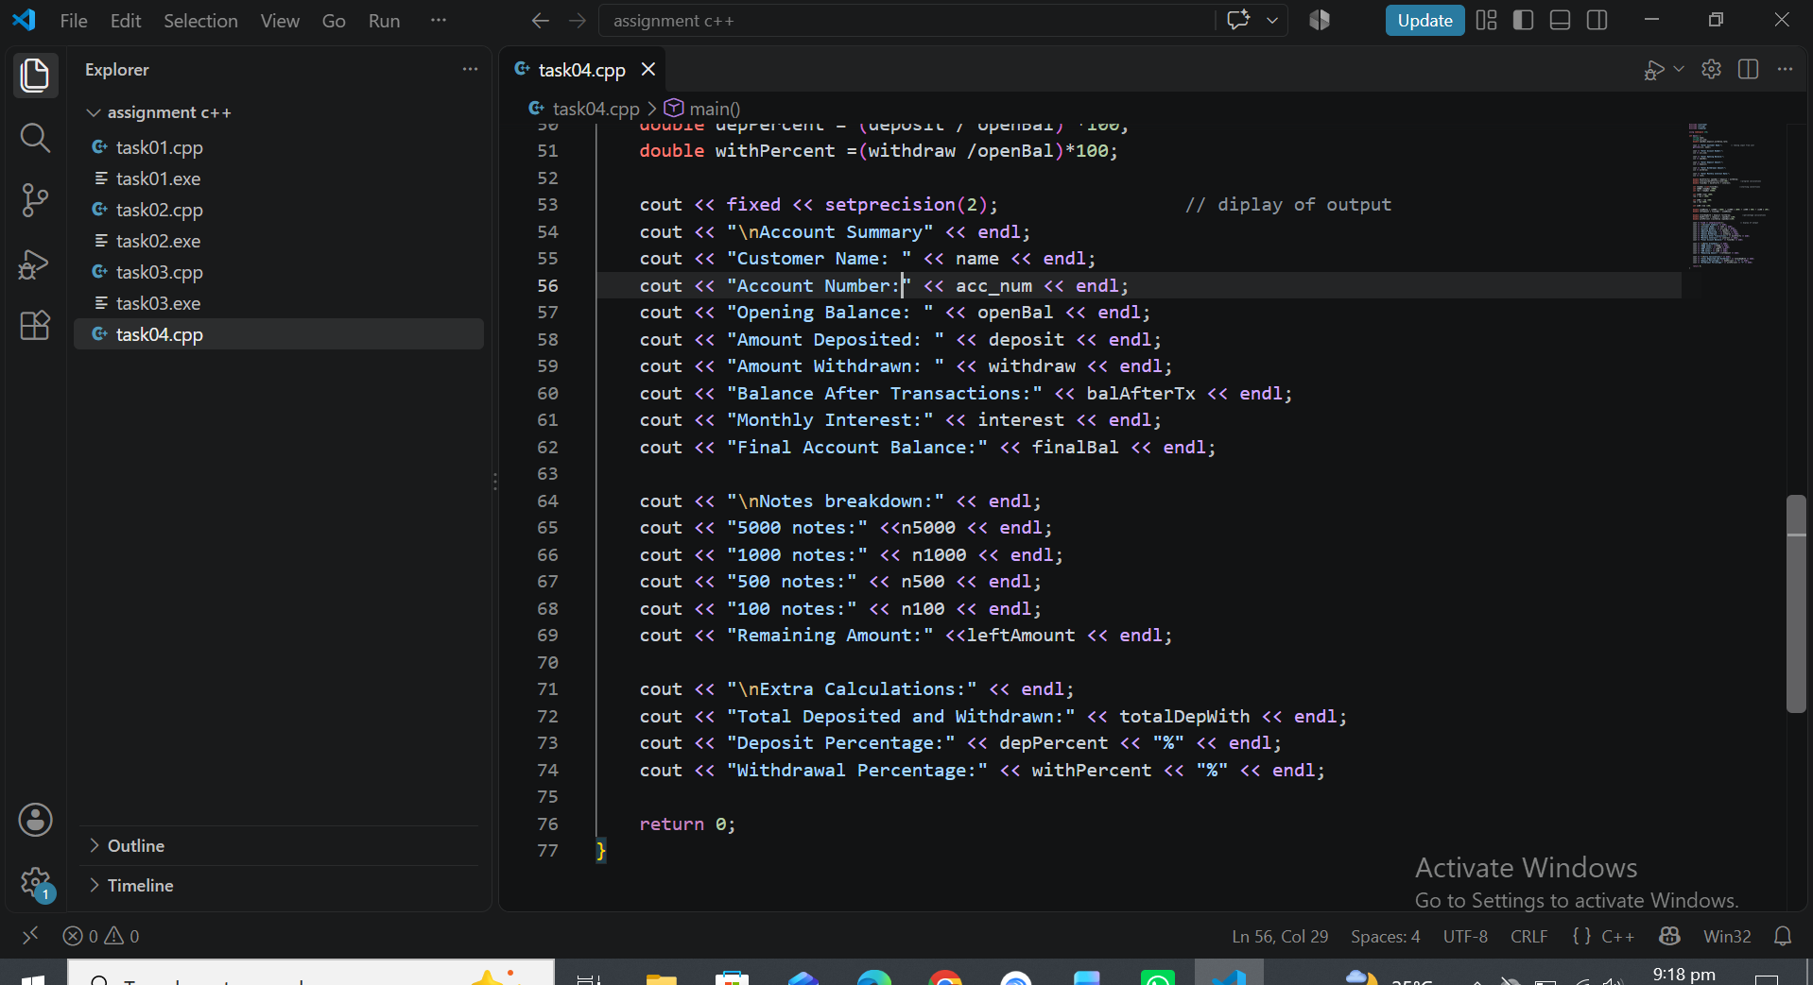

6) SCREEN SHOT OF OUTPUT :
